AWS Key Management Service (KMS) with Lambda Functions and Snowflake External Functions, Creating a symmetric key (key pair – public/private encryption using a Customer Managed Key (master key) in AWS KMS

We first need to create a KMS Customer Managed Key (master Key) which will subsequently be used to create sub keys from this master key which can be used by clients for encryption
You can do this either through the AWS Console or the AWS CLI.

Option A: Using the AWS Console
- Go to the KMS service in the AWS Management Console.
- Click Create key.
- Choose Symmetric (most common; good for encrypt/decrypt).
- Select Key usage: Encrypt and decrypt.
- Give it an alias, e.g., alias/my-app-key.
- Define key administrators and users (IAM roles or users allowed to use the key).
- Finish creation.

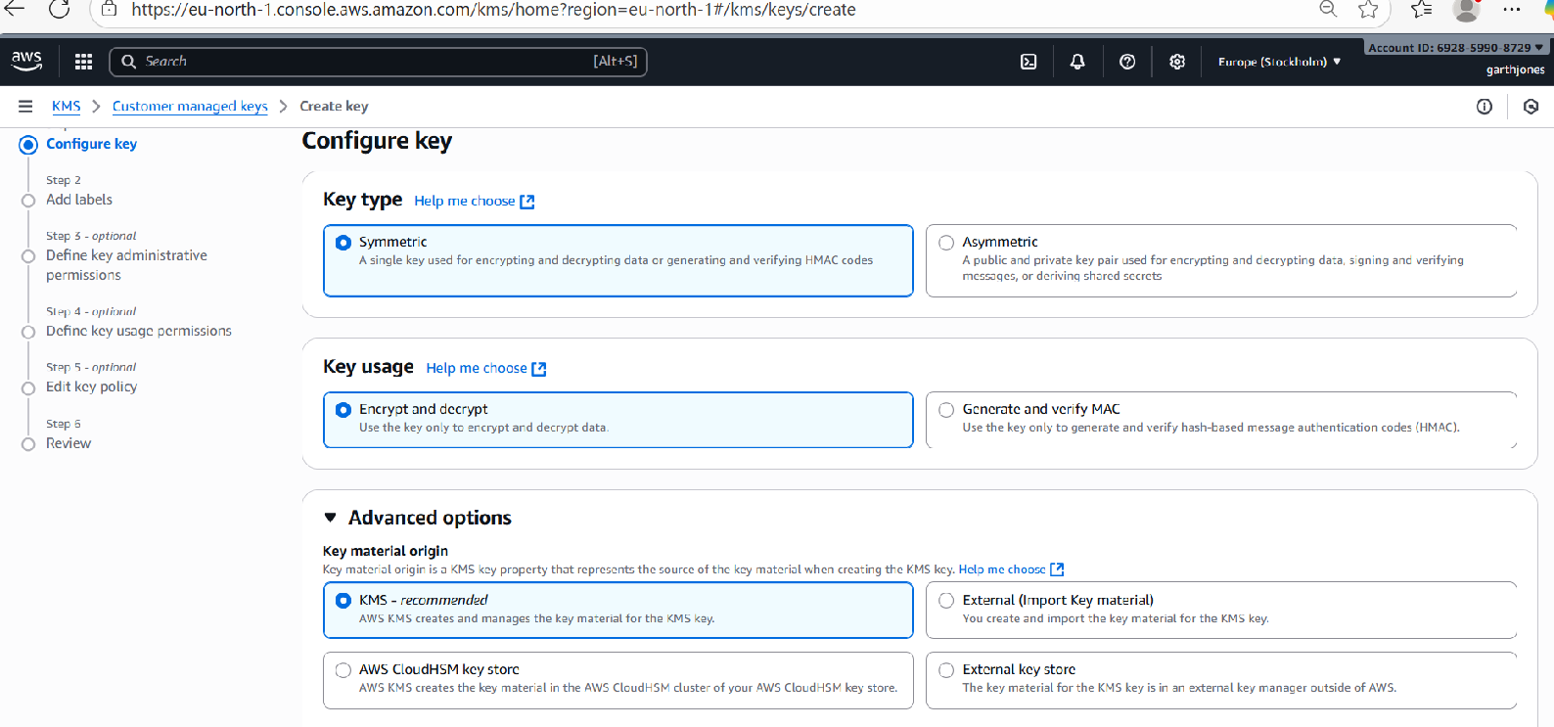
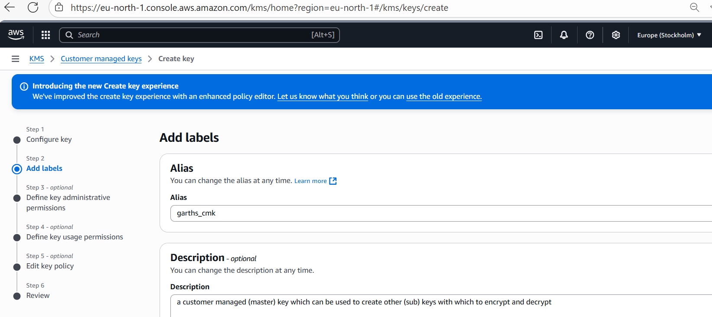

I permit the AWS service role defined for the lambda function to be an administrator for this Key (and therefore have the permissions to delete/manage the key):

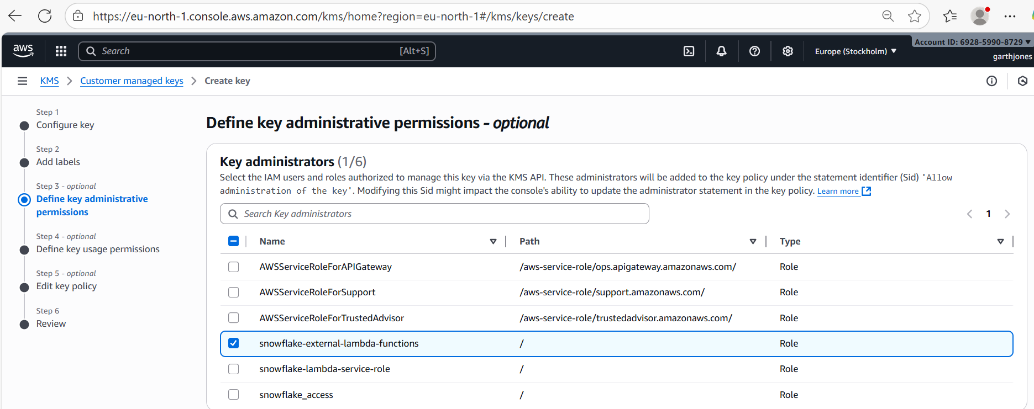

I also permit the lambda function service role to use the CMK so as to generate sub keys:
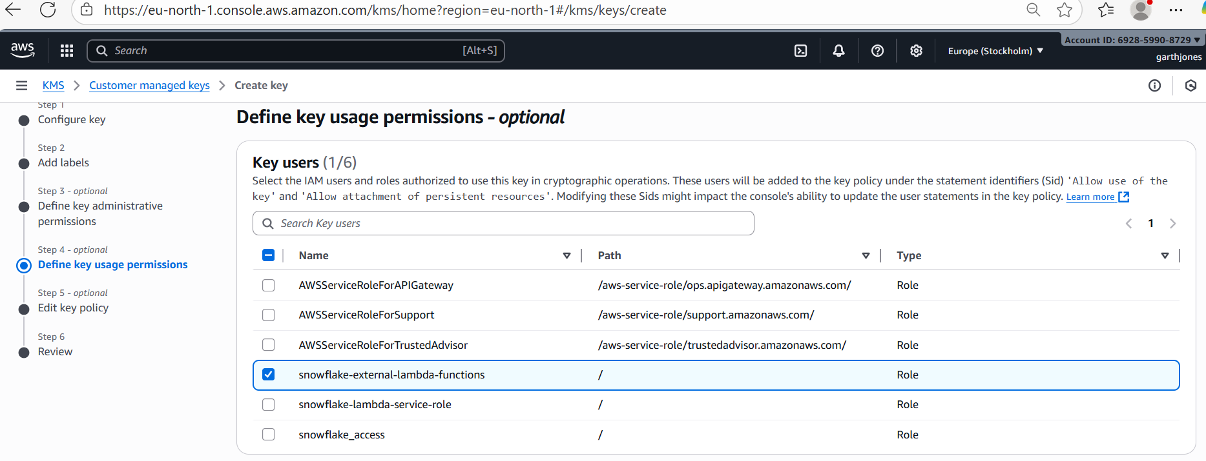

we check the IAM policy for (service) role for the CMK so that we can see that it permits the lambda function service role to use the CMK, but we do also need to (subsequently) update the permissions within the Lambda function service role itself to use the CMK – that role also needs to have that permission added into its policy – to use that service:

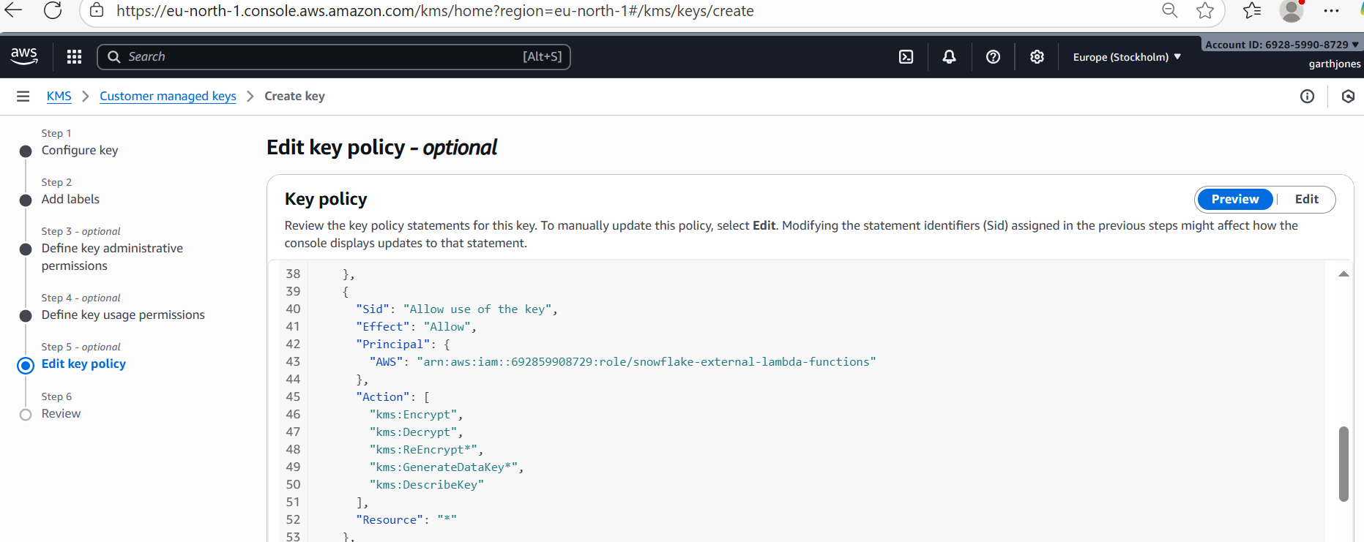

we review the key config and create it:

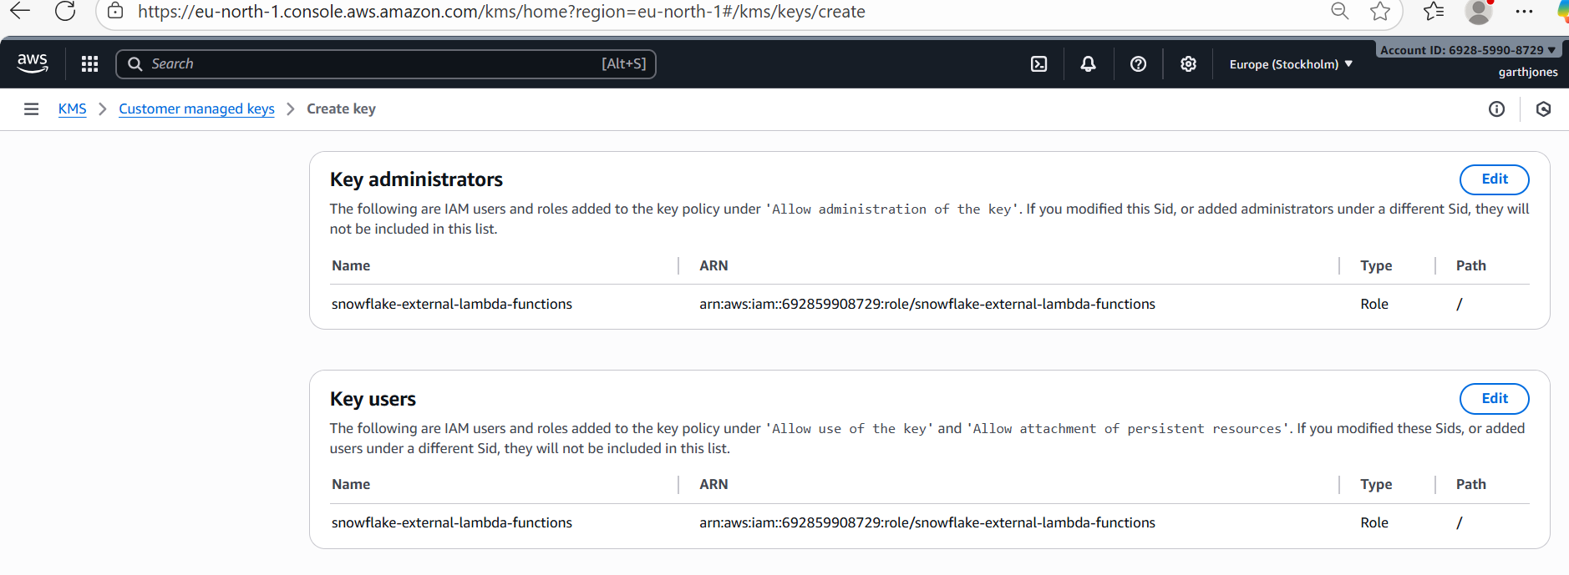

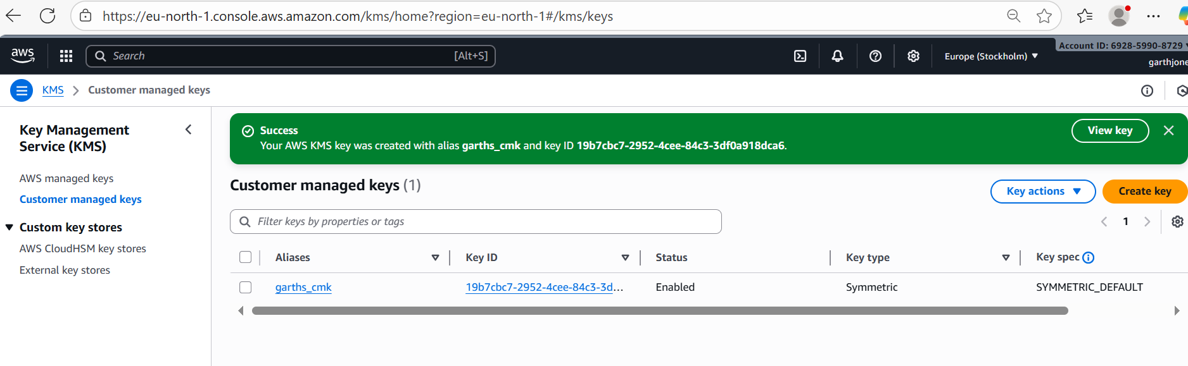

Make a note of the ARN of the key, which in this case is: arn:aws:kms:eu-north-1:692859908729:key/19b7cbc7-2952-4cee-84c3-3df0a918dca6

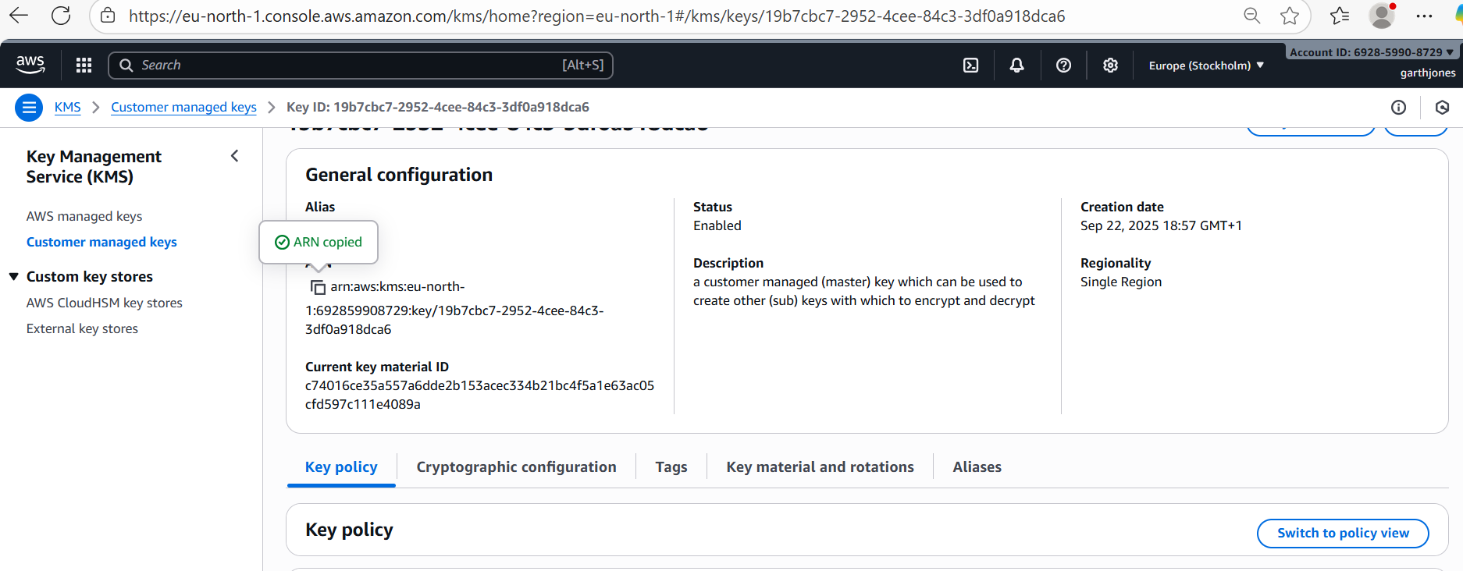

As discussed above, although we have permitted the CMK to be used by the lambda_function service role (by amending the IAM policy of the CMK), we also now have to amend the policy of the lambda_function service role itself in order to use the CMK (so the policies have to be amended on both sides of the relationship between the CMK and the lambda function):

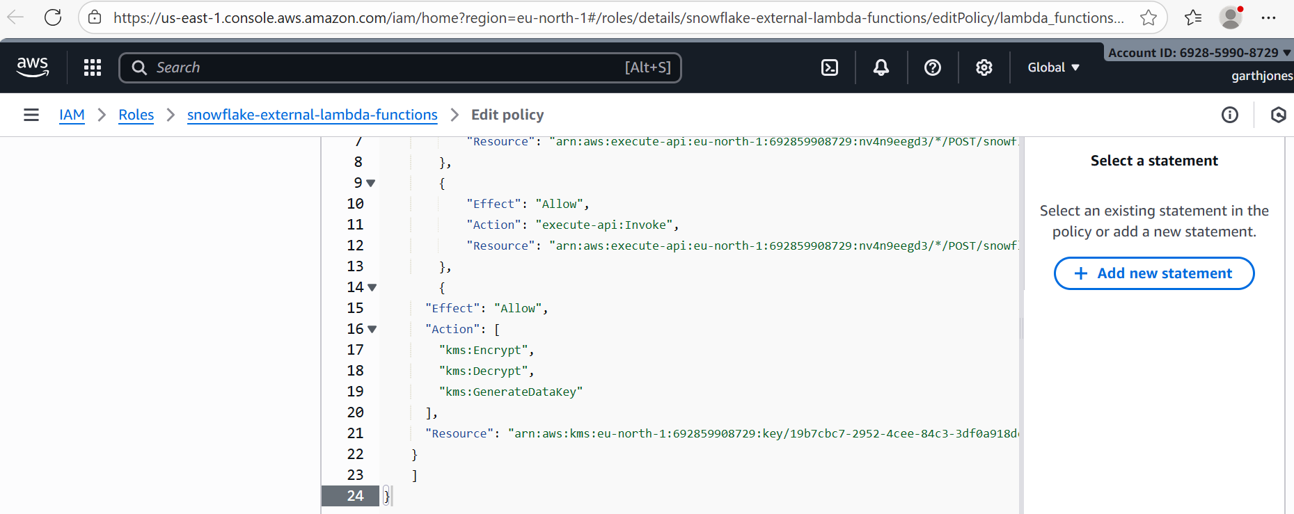

on the reviewing the permission in the policy for the lambda_function service role we can now see that the service role has two permissions, one to interact with the API_Gateway and another to interact with the Key Management Service for a specific CMK (arn).

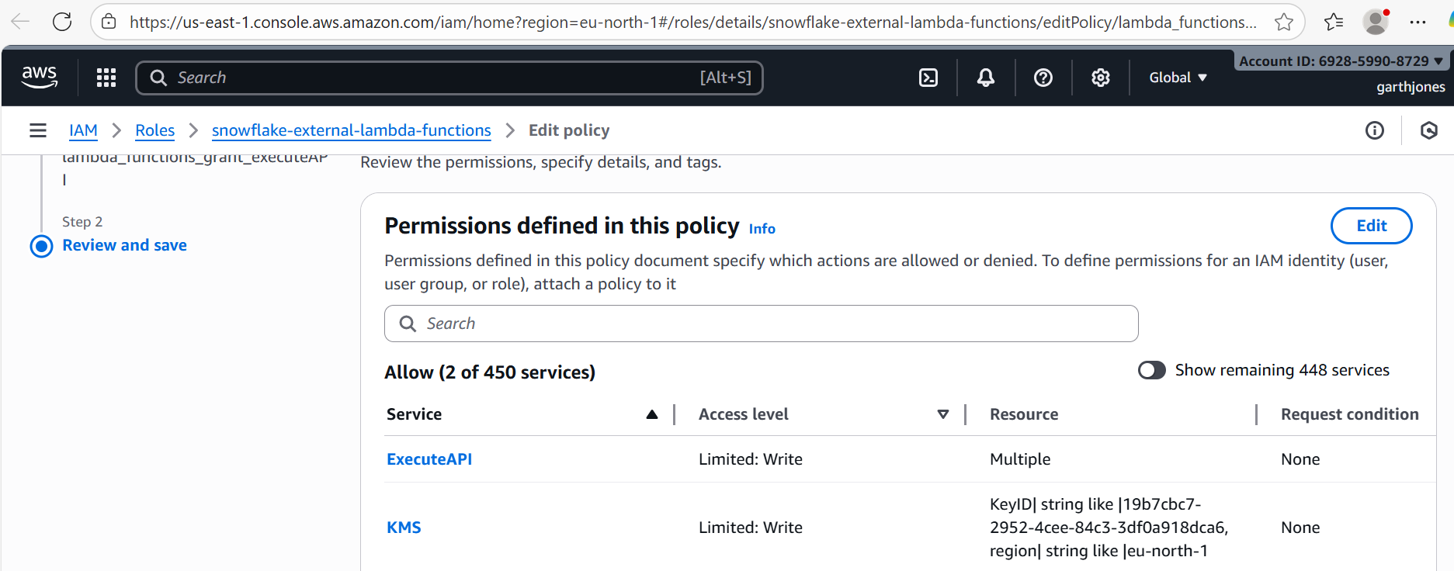

Next Steps:

Lets review what we’ve done and what we still need to do:

Putting it together
- ✅ You define the CMK and grab its ARN. – done
- ✅ You update the CMK key policy to allow a pre-existing lambda function execution role to use the CMK key. (note if there isn’t already an existing lambda function execution role you need to define one) - done
- ✅ You attach an IAM policy with KMS permissions to the Lambda’s execution role for the CMK (i.e. you update the existing lambda function policy for the pre-existing lambda function execution role using the CMK ARN). - done
- we define the ‘CMK’ lamba function which will be calling the CMK and using the CMK and put that function under the pre-existing lambda function execution role which now has all of the CMK permissions, at this stage the code is only defined to create a key, using ARG – user_id and OP_code as CREATE – NOT DONE, n.b we are referencing the code in the following URL - https://medium.com/snowflake/how-to-use-snowflake-external-functions-for-custom-data-encryption-ed04c56fc7a5 and the section of script which only handles this conditional statement at the moment (i.e. just the create key part of the script): opcode == 'CREATE'
- ✅ You store the ARN in the ‘CMK’ Lambda function’s environment variable (MY_APP_CMK) prior to testing the ‘CMK’ Lambda function’s because the CMK is referred to within the code via an environment variable.
- We test the code for creating a key only and our test scenario (i.e. the test JSON script – will only contain ARG = USER id (just create a fake one) and OP_CODE = ‘CREATE’ as the two parameters, and we will note the created key’s attributes, i.e. key_id and the hex version of the plain_text and the hex version of the cipherblob of the key, note we will need to check that this step actually creates a sub_key in AMS_KMS or the next step to call the created key will not work
- If the ‘create key’ works we will modify the function to also accept as the two parameters ARG = ciperblob, OP_code = decrypt and we will check whether the script successfully returns the plaintext and key_id for the correct key
- The next step (broadly) will be to call this function from snowflake, but of course before we do that, we have to add this function to the API, the API stage, create a resource/method etc. further we need to consider whether the ‘create’ and ‘decrypt’ parameters and the function call should be updating records in a table, in which case we need to consider carefully how we execute the function – the kind of SQL statement required in SNOWFLAKE to ensure that the table recording the key properties (both the cerated and the decrypted values) are correctly generated and stored for test purposes.

